 | Year 11 Methods  Week 8 Quiz | $$\frac{}{25}$$

Name: __________________
1. | Given the graph, complete the following:  a) Domain  b) Range  c) Vertex  d) Axis of symmetry  e) y-intercept  f) x-intercepts  g) Max or Min | 7
2. | The interval represents which of the following?  - The set of all real numbers greater than 6  - The set of all real numbers less than 6.  - The set of all real numbers greater than or equal to 6.  - The set of all real numbers less than or equal to 6. | 1
3. | On what interval is the function from question 1 increasing?  a) b) c) d) | 1
4. | Explain why x² + 81= 0 DOES NOT have a real solution. | 1
5. | Which method can’t you use to solve this problem? x² – 47 = 0  Circle one: Factoring Square Roots Quadratic Formula  Explain why: | 2
6. | What are the two mistakes in setting up the quadratic formula:  Solve: 2x² – x – 6 = 0 | 2
7. | Determine the nature of the roots of the equation  a) No real roots  b) One real rational solution  c) Two real solutions (2 rational roots)  d) Two real solutions (2 irrational roots) | 1
8. | Solve the following: | 6
9. | 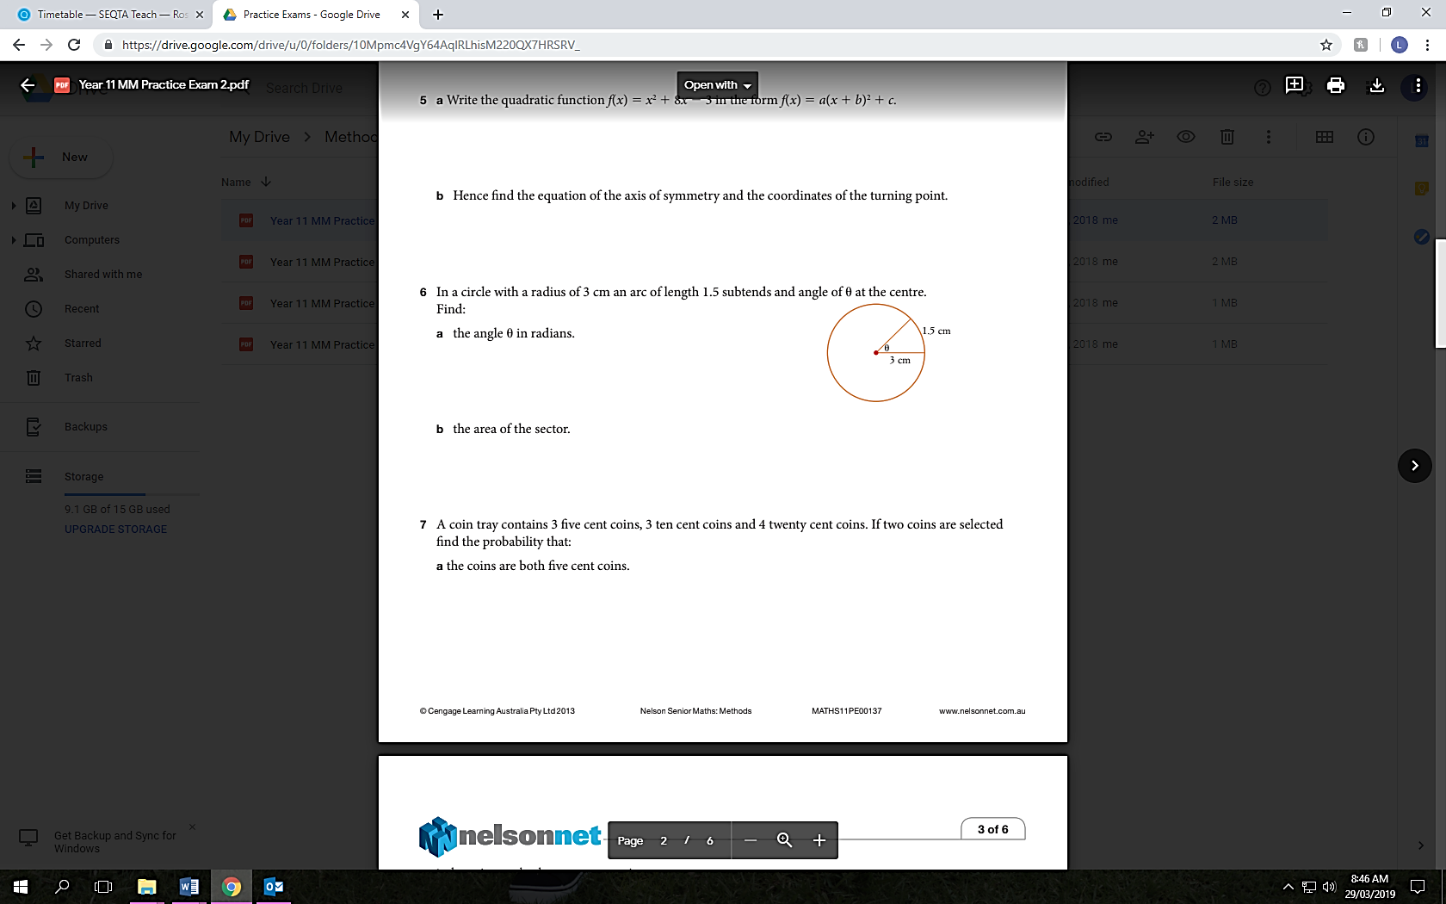 | 4

